TanárBlog tananyagbank www.tanarblog.hu

ÓRAVÁZLAT

CÍM: Celebrating Christmas – Spoken English

SZINT: B2 (és felette), emelt szintű érettségire, vagy középfokú nyelvvizsgára készülőknek különösen ajánlott

CÉLOK: A ’karácsony’ témakör kidolgozása, hallás utáni értés szövegértés fejlesztése, az ’ünnepek’ kifejezéseinek használata, kommunikáció, hétköznapi, beszélt angol kifejezések tanulása

KÉSZSÉGEK: Hallott szöveg értése / Beszéd

AMI AZ ÓRÁHOZ SZÜKSÉGES:
Interaktív tábla
SMART Notebook szoftver
Hangfalak a laptophoz, hogy le lehessen játszani a hanganyagot
Nyomtatható feladatlap (Word formátumban - itt a csomagban található)
Notebook fájl (Notebook 10 formátumban – itt a csomagban található)

ÓRA MENETE:
1. Az óra elején 1 perc alatt írjanak a diákok annyi szót, amennyit csak tudnak a ’Christmas’ szóra asszociációként. Ezután párban hasonlítsák össze, majd a legérdekessebek, legviccesebbeket gyűtsük össze az egész csoporttal. (10 perc)

2. Szinte biztosan lesz olyan, aki az ’ajándék’ (present, gift) szót is írja asszociációként. Ehhez kapcsolódva nyissuk meg a tananyaghoz tartozó Notebook fájlt, ahol az első oldal képeket tartalmaz vicces karácsonyi ajándékokról. FONTOS: hogy mik is az ajándékok, az úgy derül ki, ha a képek alatti részt ’letöröljük’, azaz a törlővel kiradírozzuk a fehér színű festéket! Találgassanak a diákok, hogy mik is lehetnek az ajándékok, majd mutassuk meg, és szavazzunk a legviccesebb, legfurább stb. ajándékra (mindegyik ajándék valós, és megrendelhető!) (5 perc)
Megj.: ha esetleg dupla óránk van, akkor itt, az óravázlat végén található részletes leírás a vicces ajándékokról.

3. Osszuk ki a feladatlapot a diákoknak, ahol csinálják meg az első feladatot. Esetleg párban is megoldhatják a feladatot, majd lépjünk a Notebook fájlban a 2. oldalra, ahol lejátszhatjuk a hanganyagot a diákoknak (ehhez az oldalon található képre kell kattintani). Miután maghallgatták / elolvasták a szöveget, ellenőrizzük a feladatot a Notebook fájl 3. oldalára kattintva. (Megj.: itt szintén úgy láthatjuk a helyes megoldást, ha a a táblatörlővel a kérdések melletti téglalapot letöröljük). (15 perc)

4. Kattintsunk a Notebook fájl 4. oldalára, ahol a feladatlapon is megtalálható kérdések szerepelnek. Adjunk 5 percet, hogy párban megbeszéljék a kérdéseket, majd az egész csoporttal röviden beszéljük meg a lehetséges válaszokat. (10 perc)

5. Ha gyorsabban végeztünk a feladtokkal, és az órából van még 10 perc, akkor játszhatunk a pörgettyűvel ☺ a Notebook fájl 6. diáján. Ehhez a következő játékmenetet javasoljuk:
a) olvassák el az órához tartozó kifejezéstárat (Expression bank) kis csoportokban, majd egymás között felosztva a kifejezéseket, próbálják meg 2 perc alatt megtanulni az összeset. Érdemes megmondani a diákoknak, hogy szavakat fognak kapni, és azokból kell a kifejezésekre PONTOSAN emlékezniük.
b) lépjünk a Notebook fájl 6. oldalára, ahol a pörgettyű nevű interaktív játék található (hasonlít a szerencsekerékre). Itt kattintsunk a pörgettyűre bárhol, majd a csoportoknak sorban azzal a szóval kell kifejezést mondani, amit a pörgettyű ad. Ha egy szó vélatlenül kétszer szerepel, akkor lehet ugyanazt mondani, amit már mások mondtak – nem baj, ha ismételnek, így még érdekesebb is a játék. (5 perc)

Megoldások:
1.F, 2. T, 3. F, 4. F, 5. T, 6. F, 7. F, 8. F, 9. T, 10. F

Megjegyzések:
Az alábbiakban található részletes ismertető a vicces ajándékokról.

DOG LAMP

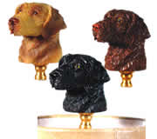
Here is a lovely and tasteful gift for the person who would love to have a dog for companionship, but is not interested in the more biological aspects of the dog, such as eating, barking, drooling and attempting to make weewee on every square inch of the planet.
This is an almost semi-lifelike dog statuette that doubles as an attractive and practical lamp. Picture the scene: It's a rainy evening, and you're snug in your living room, reading by the light of your dog. From time to time you look up from your book and say: ''Do you want to go out, Scamp?'' But Scamp never does. Good Scamp!
And if, later that night, a burglar enters your home, you can use Scamp to club him on the head. You can even take Scamp for a walk, if you have a really long extension cord.

CAFFEINATED SOAP
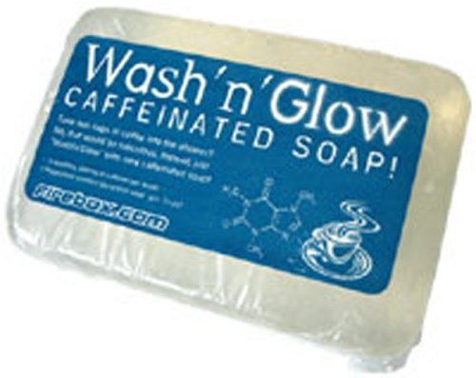
We've all exclaimed the following exclamation a million times: ''I wish there were some way I could absorb caffeine directly into my body while showering!''
Well, now there is a way, in the form of Shower Shock brand caffeinated soap. Each four-ounce bar of Shower Shock contains enough caffeine to provide the consumer with 200 milligrams of caffeine per shower, for 12 showers. The manufacturer states that this caffeine ''is absorbed through the skin.''
This breakthrough concept will make a fine gift for those people on your holiday list who do not have time to drink coffee manually, or simply dislike it. When these people need a quick ''pick-me-up'' at work or school, all they have to do is remove their clothing, pour some water on themselves, and whip out their bar of Shower Shock. Then they're back to work, feeling refreshed and alert. This will be helpful when they talk to the police.

HAIR-CUTTING UMBRELLA
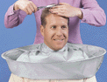
If you are like many people, you are constantly on the lookout for a gift idea that is not only practical, but also makes the wearer's head look like a human cheese ball on an hors d'oeuvres platter.
Well, look no farther than this amazing hair-cutting umbrella. It is designed to be worn during home haircuts, to prevent the hair from falling on the home-haircut victim. However, we think this item would look good anywhere, as well as providing many practical benefits. For example, have you ever been at the movies, and you grab a handful of popcorn, but when you put it in your mouth, some of the popcorn falls out? Sure you have. And usually, to retrieve that popcorn, you have to root around between your thighs. Well, if you were wearing this haircutting umbrella, that popcorn would be easily accessible, right around the base of your neck.
There are countless other uses for this fine product. We can't even count them, that's how many there are.

NAP-STRAP AIRLINE PASSENGER HEAD-RESTRAINT DEVICE

Here's the ideal gift item for anybody who flies on commercial airplanes and is basically immune from embarrassment. This is a restraining device that wraps around your head and attaches to your seat, so that you can fall asleep without having your head flop over, leaving you drooling into the lap of the businessperson seated next to you. What do you care if you look like an idiot? Let the other passengers laugh at you and put leftover airline food in your hair! You're getting your rest!
This is also a great item for people taking long car trips. Although we do not recommend it for the driver, unless the road is really straight.

BIRD DIAPERS

Is there somebody on your holiday gift list who has a pet bird? And is that bird constantly making bird droppings all over the place? If so, we have the ideal gift for that person: a cat.
Ha ha! But seriously, you need to give that person a batch of FlightSuits brand bird diapers. Yes: bird diapers. We didn't believe it ourselves at first, but it appears to be absolutely true. This product comes from the folks at Avian Fashions (''Dare to think outside the cage!'') whose phone number is 888-412-POOP.
FlightSuits are little fabric deals with fabric fasteners that you attach to your bird. They come in a variety of colors and sizes, including a new model designed to fit ducks. The FlightSuit features a patented ''V''-pouch design that has many scientific benefits in regards to the handling of the bird's poop. This means that you no longer have to leave your bird at home when you go to the mall, parties, business meetings, weddings, funerals, etc. The Flight Quarters website (www.birddiaper.com/index.html) has technical details, as well as many moving testimonials testifying to the happiness that this product has brought into their lives.
We here at the Holiday Gift Guide can honestly state that, in all our years of evaluating quality merchandise, we have never encountered a bird diaper of this stature.

TALKING TOILET-PAPER DISPENSER

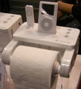
Just when you think we have already discovered every possible benefit that technology can give us, somebody comes up with an idea that makes you realize that you are correct.
This is just such an idea. This is a toilet-paper dispenser that contains an electronic device, so that you can record a message on it. When a person pulls on the toilet-paper roll, the device plays the message back, with a level of fidelity so low you have to hear it to believe it.
The talking toilet-paper roll would be a terrific addition to any guest bathroom. You can record music on it, so your guests can enjoy, say, a little Barry Manilow while they are ''finishing their business.''
We also think this would be a great motivational tool for businesses. Picture the scene: You're an employee of a large corporation. You go to use the bathroom. When you grab some toilet paper, you hear the voice of your corporate CEO saying: 'Hurry up! As long as you're in here, you are not improving our 'bottom line!' Ha ha! Get it? But seriously, please limit yourself to two squares of toilet tissue.''

BUBBLE BUDDY BACON-FLAVORED DOG BUBBLES

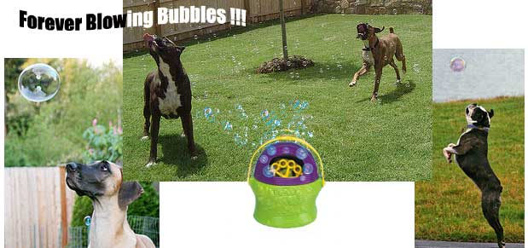
We all love dogs, and for a good reason: They are morons.
We mean that in a good way. We mean that dogs are extremely enthusiastic, always ready to play and fetch sticks and jump out of vehicles going 75 miles per hour.
Dogs also love to chase, and try to bite, soap bubbles. It's an instinct they acquired millions of years ago, when their wolf ancestors had to protect their young from wily predators such as the saber-toothed tiger, which would try, usually successfully, to distract the wolves by blowing bubbles.
That is the biological basis for this holiday gift concept for the dog on your list. It consists of a bubble dispenser and four ounces of bacon-flavored bubble solution. The Internet site we ordered from states that if you buy this product, you and your dog will, quote, ''have so much fun, you'll want to order refills now!''
We have no reason to doubt this claim, other than the report of our photographer, Chuck, who e-mailed us as follows:
''In extensive consumer testing, which consisted of trying to take pictures of five dogs, we have learned that the Bubble Buddy bubble-blowing toy for dogs, with bacon-scented bubbles, is of absolutely no interest to said dogs. Humans could detect no scent of bacon in the bubble mixture, nor could the dogs, by all evidence.''
(For the record, these five dogs all belong to a professional journalist, so we know they are fair and balanced.)
So we're not saying this product actually works. We're just saying, hey, WE bought it, so we're putting it in the Gift Guide.

DOGGLES
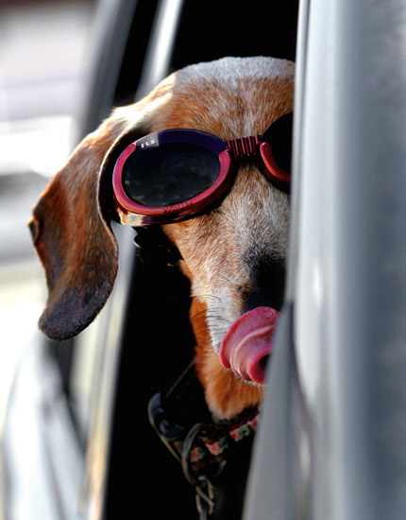
If you are a dog owner, you know that one of your dog's most important responsibilities is to ride in the car with you with its head sticking out the window, so that it can bark violently whenever it sees a potential enemy threat in the form of another dog, a squirrel, a mailbox, a flying insect, a cloud, nothing, etc.Yes, protecting your car is a vital dog task, but it is also a physically demanding one. A dog sticking its head out the window, hour after hour, is likely to develop a condition that veterinarians call Wind Blowing On The Eyeballs Syndrome (WBOTES) which, if not treated, can, over time, cause the dog to blink. Of course your dog would never complain, but if it could talk, it would say to you: ''Hey! Idiot! I need goggles!''
That is why you should give your dog a pair of these Doggle brand doggy goggles, which will enable your dog to protect you and your vehicle in style and comfort for many years, until it becomes old and feeble and goes to that Big Kennel in the Sky, at which point it can be replaced by the following tasteful item in our Holiday Gift Guide.

